**PRACTICE - 1**

CB.SC.I5DAS21058

SOWGANDHIGA.S

1. Depth First Search:

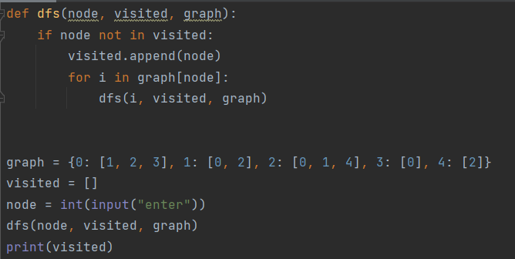

Output:

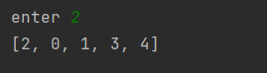

1. Breadth First Search:

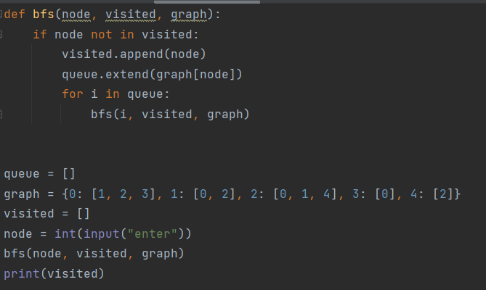

Output:

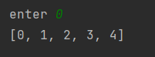

1. Prims’s Algorithm:

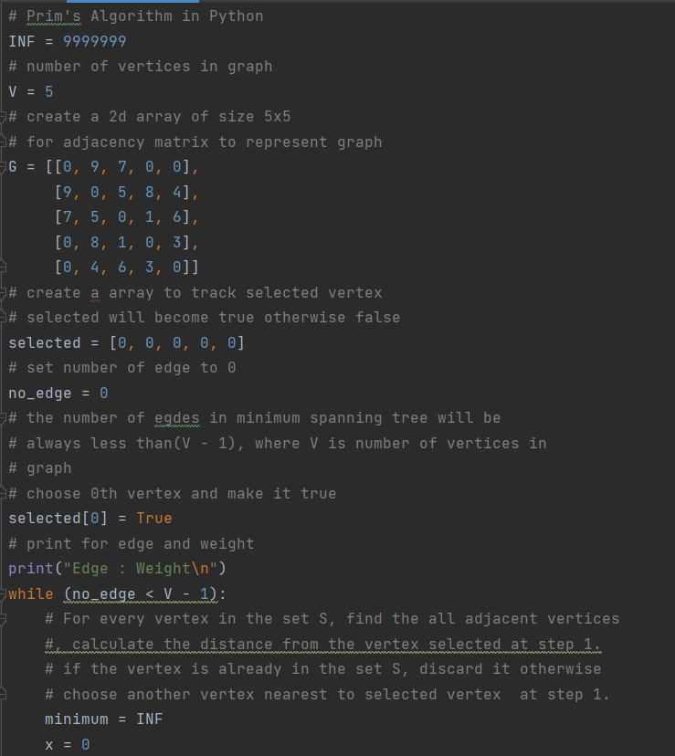

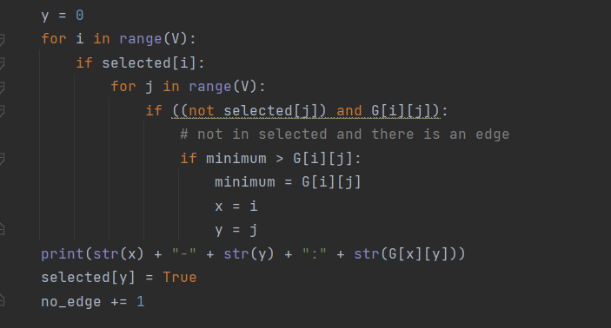

OUTPUT:

